**Answer 5:**

docker build -t dependencyimage -f DockerfileDepImg .

docker build -t finalimage -f FinalDockerfile .

**Tagging and pushing to Azure**

docker tag finalimage:latest crm22aie243.azurecr.io/finalimage:latest

docker push crm22aie243.azurecr.io/finalimage:latest

**Screenshot from local :**

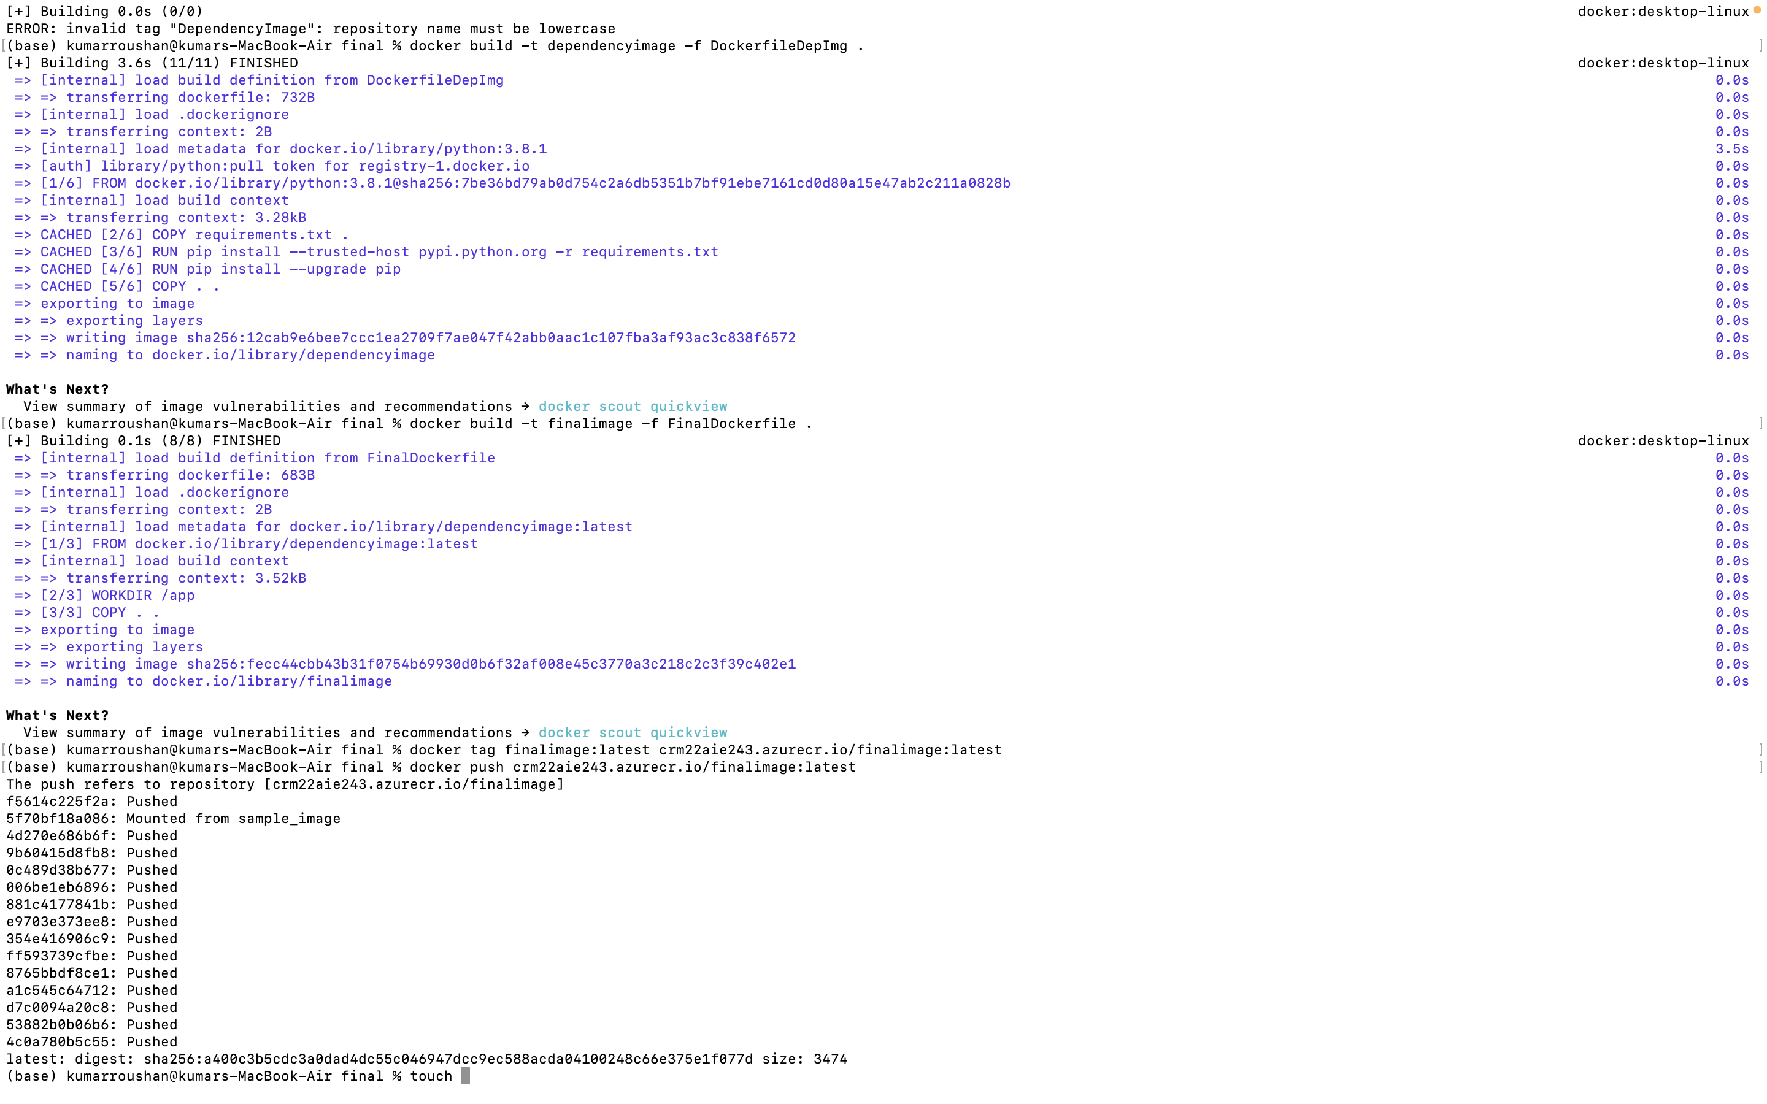

**Screenshot from Azure container for images which I pushed to Azure.**

az acr repository list --name crm22aie243.azurecr.io --output table ( We can see finalimage in azure)

